Indy Scouting Report
Scout: Frank Cacioppo
Team: Tampa Bay Titans
Opponent: Indy Express
Win- Loss: 5-2

Offensive Notes:
- #7 is an excellent offensive rebounder, however, he tends to go “over the back” often
- Stay in front of #6, he gets out of control at times and you can draw a charge
- #10 also likes throwing the “pump fake” and going around you to drive the lane; make him put the ball on the floor as he gets a little out of control, might be able to draw a charge
- #8 has excellent 3-point range
- #6 has excellent 3-point range
- #9 has excellent 3-point range
- #10 has excellent 3-point range
- Get back on defense, they like to get out and run after a missed basket by the opponent
- They like to set picks all over the floor to get open shots

Defensive Notes:
- They defend the 3 very well and are not afraid to contest shots on the perimeter
- They leave the lane wide-open since they defend the perimeter aggressively, take advantage of it
- #7 is an excellent defensive rebounder
- Will “diamond trap” 1-1-2-1 occasionally; they use this scheme to try to slow your tempo or at least break the rhythm of your offense. Example below

Diamond Trap
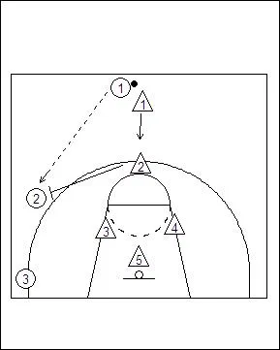
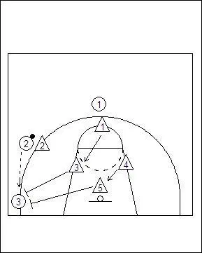
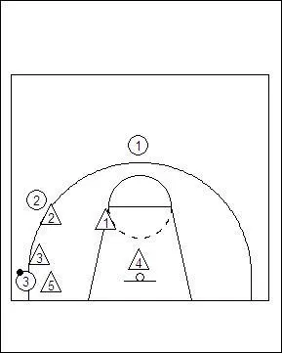

- Will press full court 1-2-1-1
- #4 is a very active defender; seems like he is “everywhere”
- Get out and run, they sometimes get lazy while getting back on defense when they are not pressing
Key Statistics:
GP: 7
PPG: 113
APG: 15.7
Off RB: 14.9
Df RB: 34.9
Blks: 2.3
Stls: 6
TO: 14.7
3-PT mpg: 13.4
FG %: 47.6%
FT % : 74%
3-PT %: 40.5%
2-PT %: 52.1%

